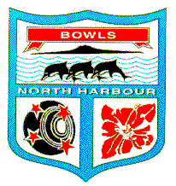
BOWLS NORTH HARBOUR INC

OPEN MASTERS (70 & OVER) ANY COMBINATION
Triples

Monday 18th March 2019 Sunnybrae Bowling Club

Entries Close with Bowls North Harbour Centre Manager Friday 15th March 2019

Post entry to Bowls North Harbour, P O 82 Box Orewa

PLEASE PRINT DETAILS CLEARLY

Name Skip

Name Two

Name Lead

Contact Phone

E-mail

Players Signature -----------------------------------------------------------------------------

Entry fee of $60 per team must accompany all entries
Cheque or direct debit: 03-0104-0982950.00 quote Name and ref: MT
NO REFUND AFTER DRAW HAS BEEN DONE
UNLESS EVENT IS CANCELLED

I hereby agree to abide by the Conditions of Play set down and any decisions made by Bowls North Harbour in order to complete the event.

Signed Player ---------------------------------- Date

